ITOPF Appoints New Chairman
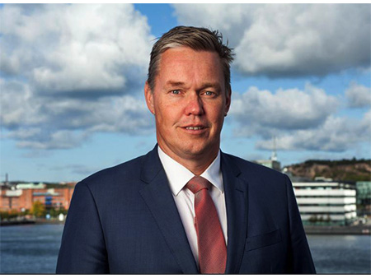
Erik Hånell, President & CEO of Stena Bulk, ITOPF’s new Chairman

Paddy Rodgers stood down as ITOPF’s Chairman at the end of its board meeting in Shanghai on 5th November, noting that he had thoroughly enjoyed his tenure on the board and had valued the opportunity to contribute to ITOPF’s strategic direction and to the work of its highly regarded international team. The board voted unanimously to appoint Erik Hånell, President & CEO of Stena Bulk, as its new Chairman. Erik has served on ITOPF’s board for the last seven years and is also on the board of Skuld P&I Club. ITOPF’s Managing Director, Karen Purnell, said that she, and the team, would miss Paddy’s energetic contributions to the work of the organisation. She welcomed Erik’s appointment saying that he would bring a wealth of experience, particularly in areas that will be important as ITOPF further enhances its reputation as the global resource for preparedness and response to ship source pollution.

Notes on ITOPF
1. ITOPF was established as a non-profit making service organisation in 1968. In the early days its principal function was the administration of the TOVALOP voluntary oil spill compensation agreement. This scheme terminated in 1997, however, since the early 1970s, ITOPF has also provided a broad range of technical services in the field of marine pollution to and on behalf of shipowners, their P&I insurers and other groups such as the International Oil Pollution Compensation Funds, as well as to the community at large.

2. ITOPF's Membership currently comprises around 8,000 owners and bareboat charterers of approximately 13,600 tank vessels with a total gross tonnage of over 430 million GT. The organisation also benefits from the participation of over 810 million GT of non-tanker tonnage owned and operated by its Associates.

3. ITOPF's priority service is responding to accidental marine spills and the organisation's team of highly experienced technical staff are at constant readiness to travel anywhere in the world at a few hours’ notice. ITOPF staff have attended on-site at over 800 incidents around the world, giving the organisation unparalleled practical experience of the realities of combating marine spills.

ITOPF also:

- assesses the damage caused by spills to the environment and economic resources;
- provides advice on the technical merits of claims for compensation;
- conducts contingency planning, advisory and training assignments;
- produces a range of technical publications and films; and
- maintains various databases as well as a website at www.itopf.org.

4. For further information contact:

Dr Karen Purnell (Managing Director)
Mrs Deborah McKendrick (Information Officer)
ITOPF Limited
1 Oliver’s Yard, 55 City Road, London EC1Y 1DT

Tel: +44 (0)20 7566 6999
Fax: +44 (0)20 7566 6950
Email: deborahmckendrick@itopf.org
Web: www.itopf.org

