2017 Tanker Oil Spill Statistics: Positive downward trend continues
Statistics for oil spills from tankers for close to five decades show a progressive downward trend. The average number of spills greater than, or equal to, 7 tonnes in size has continuously reduced and, since 2010, averages around 7 per year. When we look at large spills, i.e. greater than 700 tonnes, the yearly average, which was around 25 in the 1970s has reduced dramatically to less than 2 since 2010.
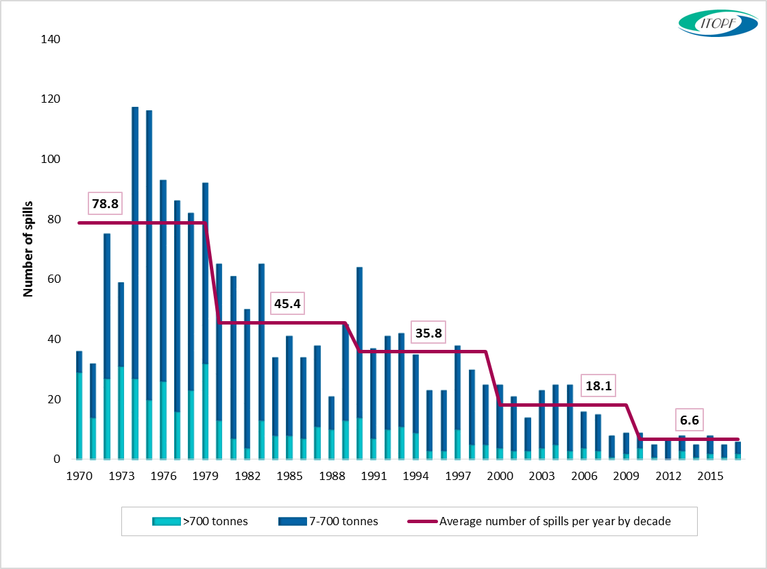
Number of large (>700 tonnes) and medium (7-700 tonnes) spills recorded from 1970 to 2017
In 2017, two tanker incidents resulting in spills of over 700 tonnes were reported. The first occurred in the Indian Ocean and the second, which ITOPF attended on site, occurred in the Aegean Sea. Four medium sized spills (7-700 tonnes) were also recorded in 2017.
The estimated total amount of oil lost to the environment through tanker incidents in 2017 was approximately 7,000 tonnes, the majority of which can be attributed to the two large incidents mentioned above.
Despite an overall increase in oil trading over the past few decades, it is reassuring to note that oil spills involving tankers have decreased significantly meaning that some 99.99% of oil transported by sea arrives safely at its destination. However, accidents still happen, as demonstrated on 6th January by the tragic incident that occurred off the coast of China involving the oil tanker SANCHI. Learning lessons from incidents such as these will assist tanker owners and governments to continue to work together to reach the highest level of safety and environmental stewardship.

Notes for Editors
ITOPF maintains a database of oil spills from tank vessels, including combined carriers, FPSOs and barges. This contains information on accidental spillages of persistent and non-persistent oil since 1970, except those resulting from acts of war. The data held includes the location and cause of the incident, the vessel involved, the type of oil spilt and the spill amount. For historical reasons, spills are generally categorised by size, <7 tonnes, 7–700 tonnes and >700 tonnes (<50 bbls, 50–5,000 bbls, >5,000 bbls), although the actual amount spilt is also recorded. Information is now held on over 10,000 incidents, the vast majority of which fall into the smallest category i.e. <7 tonnes.
Further details are available on the statistics page of ITOPF’s website.

Notes on ITOPF
1. The International Tanker Owners Pollution Federation Limited (ITOPF) was established as a non-profit making service organisation in 1968. In the early days its principal function was the administration of the TOVALOP voluntary oil spill compensation agreement. However, since the early 1970s, ITOPF has also provided a broad range of technical services in the field of marine pollution to and on behalf of shipowners, their P&I insurers and other groups such as the International Oil Pollution Compensation Funds, as well as to the community at large.

2. ITOPF's Membership currently comprises over 7,900 owners and bareboat charterers of approximately 13,500 tank vessels with a total gross tonnage of about 426 million GT. The organisation also benefits from the participation of 792 million GT of non-tanker tonnage owned and operated by its Associates.

3. ITOPF's priority service is responding to accidental marine spills and the organisation's team of highly experienced technical staff are at constant readiness to travel anywhere in the world at a few hours’ notice. ITOPF staff have attended on-site at almost 800 incidents around the world, giving the organisation unparalleled practical experience of the realities of combating major marine spills. ITOPF also:

- assesses the damage caused by spills to the environment and economic resources;
- provides advice on the technical merits of claims for compensation;
- conducts contingency planning, advisory and training assignments;
- produces a range of technical publications and films; and
- maintains various databases as well as a website at http://www.itopf.com

4. For further information contact:

Dr Karen Purnell (Managing Director)
Mrs Deborah McKendrick (Information Officer)
The International Tanker Owners Pollution Federation Limited (ITOPF)
1 Oliver’s Yard, 55 City Road, London EC1Y 1HQ

Tel: +44 (0)20 7566 6999
Fax: +44 (0)20 7566 6950
Email: deborahmckendrick@itopf.com
Web: www.itopf.com

