2018 Oil Tanker Spill Statistics: Number of spills remains low
For close to five decades, the frequency of oil spills from tankers has shown a progressive downward trend. The average number of spills of 7 tonnes or more is now about six per year, from a high of 79 in the 1970s. The yearly average for large spills, i.e. greater than 700 tonnes, has also reduced from around 25 in the 1970s to less than two since 2010.

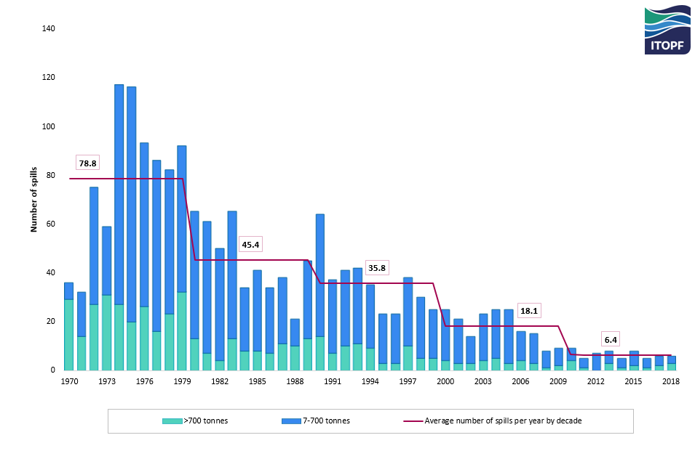Number of large (>700 tonnes) and medium (7-700 tonnes) spills recorded from 1970 to 2018
Statistics for the quantity of oil spilled show a similar trend. However, this trend can be distorted by a single large spill as shown in the figure below.
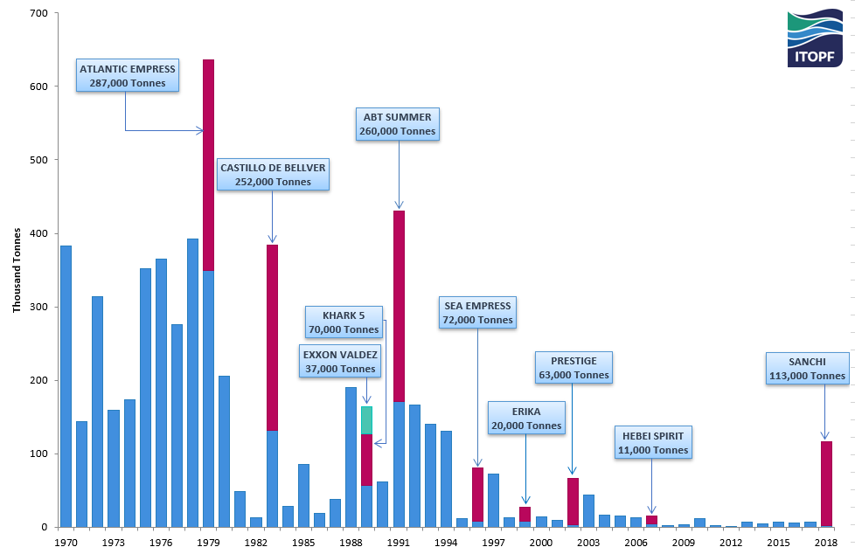Estimated quantities of oil spilled 7 tonnes and over (rounded to nearest thousand) 1970 to 2018

In 2018, three spills of over 700 tonnes were reported. ITOPF attended two of these incidents to provide technical advice, both in East Asia. Three medium spills (7–700 tonnes) were also reported.
The estimated total amount of oil lost to the environment through tanker incidents in 2018 was approximately 116,000 tonnes, the majority of which can be attributed to the SANCHI incident, a spill of non-persistent oil with significantly lower environmental impacts compared to crude oil.
The number of oil spills involving tankers remains low despite a general increase in oil trading over the years and tanker owners and governments continue to work together to improve safety and standards of operations in seaborne oil transportation.

Notes for Editors
ITOPF maintains a database of oil spills from tank vessels, including combined carriers, FPSOs and barges. This contains information on accidental spillages of persistent and non-persistent oil since 1970, except those resulting from acts of war. The data held includes the location and cause of the incident, the vessel involved, the type of oil spilt and the spill amount. For historical reasons, spills are generally categorised by size, <7 tonnes, 7–700 tonnes and >700 tonnes (<50 bbls, 50–5,000 bbls, >5,000 bbls), although the actual amount spilt is also recorded. Information is now held on over 10,000 incidents, the vast majority of which fall into the smallest category i.e. <7 tonnes.
Further details are available on the statistics page of ITOPF’s website.

Notes on ITOPF
1. ITOPF was established as a non-profit making service organisation in 1968. In the early days its principal function was the administration of the TOVALOP voluntary oil spill compensation agreement. However, since the early 1970s, ITOPF has also provided a broad range of technical services in the field of marine pollution to and on behalf of shipowners, their P&I insurers and other groups such as the International Oil Pollution Compensation Funds, as well as to the community at large.

2. ITOPF's Membership currently comprises around 8,000 owners and bareboat charterers of approximately 14,000 tank vessels with a total gross tonnage of over 400 million GT. The organisation also benefits from the participation of over 800 million GT of non-tanker tonnage owned and operated by its Associates.

3. ITOPF's priority service is responding to accidental marine spills and the organisation's team of highly experienced technical staff are at constant readiness to travel anywhere in the world at a few hours’ notice. ITOPF staff have attended on-site at over 800 incidents around the world, giving the organisation unparalleled practical experience of the realities of combating marine spills. ITOPF also:

- assesses the damage caused by spills to the environment and economic resources;
- provides advice on the technical merits of claims for compensation;
- conducts contingency planning, advisory and training assignments;
- produces a range of technical publications and films; and
- maintains various databases as well as a website at www.itopf.org.

4. For further information contact:

Dr Karen Purnell (Managing Director)
Mrs Deborah McKendrick (Information Officer)
ITOPF Limited
1 Oliver’s Yard, 55 City Road, London EC1Y 1HQ

Tel: +44 (0)20 7566 6999
Fax: +44 (0)20 7566 6950
Email: deborahmckendrick@itopf.org
Web: www.itopf.org

