ITOPF’s Annual Statistics Show a Promising Start
to the New Decade
12th January 2021
ITOPF’s annual statistics of oil spills from tankers show that there were only 3 incidents where more than 7 tonnes of oil were spilt in 2020. The total volume of oil lost in all 3 incidents was approximately 1,000 MT making it amongst the lowest on record. At a time when the annual volume of oil moved by sea is approximately 3 billion tonnes, this means that the effort to ensure oil cargoes arrive at their destinations safely is paying off.
Using ITOPF’s categorisation for sizes of oil spill, there were no large spills (>700 tonnes) in 2020 and the 3 incidents recorded were all categorised as medium spills (7-700 tonnes); with one each occurring in Europe, Africa, and Asia.
During the half century since ITOPF’s records began, the frequency of large oil spills (> 700 tonnes) has plummeted such that their occurrence is now a rarity. To report meaningful changes, ITOPF now needs to refer to its lower categorisation of spills, i.e. medium spills (between 7 and 700 tonnes).
The average number of spills greater than 7 tonnes per year in the 1970s was about 79 but this has decreased by over 90% to just 6 in the last decade, as illustrated below.
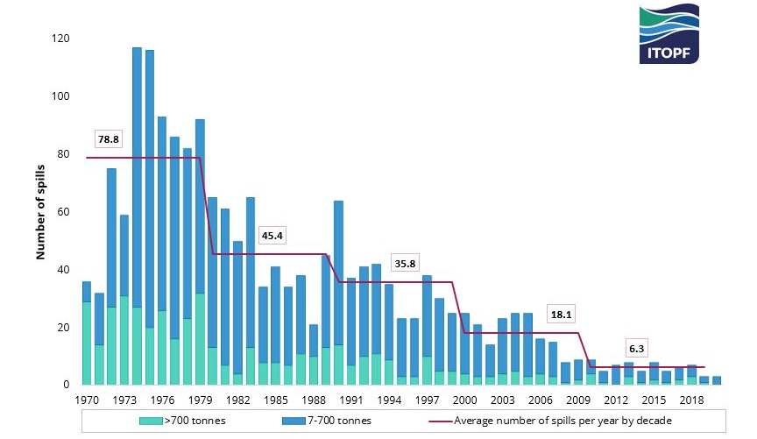
Number of large (>700 tonnes) and medium (7-700 tonnes) spills recorded from 1970 to 2020
When comparing how the oil was spilt in each decade, it is interesting to note that as the number of oil spills have decreased, the relative proportion of spills arising from allisions and collisions has increased, accounting for around 44% of all oil spills from tankers greater than 7 tonnes. Although accidents regrettably remain a possibility, the shipping industry, supported by governments, continues to strive towards a goal of zero spills, learning lessons from incidents such as these to reach the highest level of safety and environmental stewardship.

It is important to note that although ITOPF attends incidents from tankers and non-tankers, for historical reasons the annual statistics publication only reports incidents involving tankers, combined carriers and barges. Accidents involving non-tank vessels which carry oil as bunker fuel, such as container ships, bulk carriers and general cargo ships, may also be a source of pollution. This was unfortunately demonstrated following the grounding of the bulk carrier WAKASHIO off the coast of Mauritius in July 2020.

Notes for Editors
ITOPF maintains a database of oil spills from tank vessels, including combined carriers, FPSOs and barges. This contains information on accidental spillages of persistent and non-persistent oil since 1970, except those resulting from acts of war. The data held includes the location and cause of the incident, the vessel involved, the type of oil spilt and the spill amount. For historical reasons, spills are generally categorised by size, <7 tonnes, 7–700 tonnes and >700 tonnes (<50 bbls, 50–5,000 bbls, >5,000 bbls), although the actual amount spilt is also recorded. Information is now held on over 10,000 incidents, the vast majority of which fall into the smallest category i.e. <7 tonnes.
Further details are available on the statistics page of ITOPF’s website.
Notes on ITOPF
1. Established in 1968, ITOPF is maintained by the world’s shipowners and their insurers on a not-for-profit basis to promote effective response to spills of oil, chemicals and other substances in the marine environment.

2. ITOPF's Membership currently comprises around 8,200 owners and bareboat charterers of approximately 13,900 tank vessels with a total gross tonnage of over 445 million GT. The organisation also benefits from the participation of over 840 million GT of non-tanker tonnage owned and operated by its Associates.

3. ITOPF's priority service is responding to accidental marine spills from ships. ITOPF staff have attended on-site at over 800 incidents in 100 countries, giving the organisation unparalleled practical experience of the realities of combating marine spills.

ITOPF also:

- assesses the damage caused by spills to the environment and economic resources;
- provides advice on the technical merits of claims for compensation;
- conducts contingency planning, advisory and training assignments;
- is a primary source of information on ship-source spills through its technical publications, films and website (www.itopf.org).

4. For further information contact:

Dr Karen Purnell (Managing Director)
Mrs Deborah McKendrick (Senior Information Officer)
ITOPF Limited
1 Oliver’s Yard, 55 City Road, London EC1Y 1DT, UK
Tel: +44 (0)20 7566 6999
Email: deborahmckendrick@itopf.org
Web: www.itopf.org

Source UNCTAD

