Downward trend in tanker spills continues

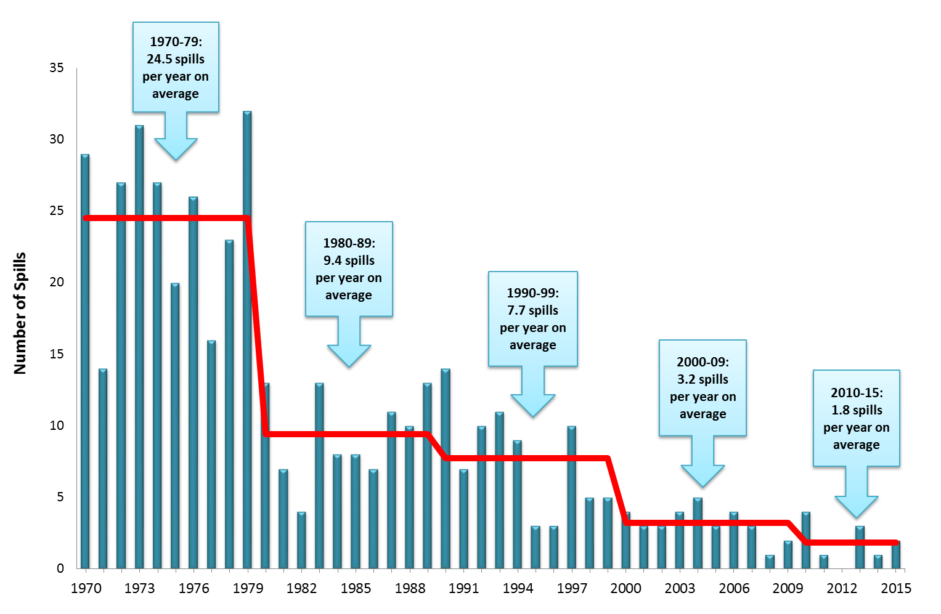
Number of large oil spills >700 tonnes, 1970-2015

Over half-way into this decade and the downward trend in oil spills from tankers continues. For the last three and a half decades the average number of incidents involving large oil spills, i.e. greater than 700 tonnes, from tankers has progressively reduced and since 2010 stands at an average of 1.8 per year.

In 2015 two spills of oil over 700 tonnes from tankers were recorded; one a crude oil spill in Singapore and the other a spill of naphtha in Turkey. ITOPF provided technical advice to the vessels’ insurers in both incidents. Six medium-sized spills (7-700 tonnes) were also reported in 2015, involving cargoes of asphalt, naphtha and slurry oil, as well as bunker fuel.

The total amount of oil lost to the environment through tanker incidents in 2015 was approximately 7,000 tonnes, the majority of which can be attributed to the two large spills.
This continuing trend in low numbers of large oil spills annually is encouraging news for tanker operators and governments alike as they continue to work to improve standards of operations in sea-borne transportation.

8th January 2016

Notes for Editors:
ITOPF maintains a database of oil spills from tankers, combined carriers and barges. This contains information on accidental spillages of persistent and non-persistent oil since 1970, except those resulting from acts of war. The data held includes the type of oil spilt, the spill amount, the cause and location of the incident and the vessel involved. For historical reasons, spills are generally categorised by size, small (<7 tonnes or <50 bbls), medium (7-700 tonnes or 50-5,000 bbls) and large (>700 tonnes or >5,000 bbls), although the actual amount spilt is also recorded. Information is now held on approximately 10,000 incidents, the vast majority of which (81%) fall into the smallest category i.e. <7 tonnes.

Further details on the number and quantity of spills from tanker accidents since 1970, together with figures and tables, are available on the statistics page of ITOPF’s website.

Notes on ITOPF
1. The International Tanker Owners Pollution Federation Limited (ITOPF) was established as a non-profit making service organisation in 1968. In the early days its principal function was the administration of the TOVALOP voluntary oil spill compensation agreement. However, for the past 45 years ITOPF has also provided a broad range of technical services in the field of marine pollution to and on behalf of shipowners, their P&I insurers and other groups such as the International Oil Pollution Compensation Funds, as well as to the community at large.

2. ITOPF's Membership currently comprises some 7,000 owners and bareboat charterers of approximately 12,000 tank vessels with a total gross tonnage of about 370 million GT. The organisation also benefits from the participation of 721 million GT of non-tanker tonnage owned and operated by its Associates.

3. ITOPF's priority service is responding to accidental marine spills and the organisation's team of highly experienced technical staff are at constant readiness to travel anywhere in the world at a few hours’ notice. Since 1978 ITOPF staff have attended on-site at over 750 incidents around the world, giving the organisation unparalleled practical experience of the realities of combating major marine spills. ITOPF also:

- assesses the damage caused by spills to the environment and economic resources;
- provides advice on the technical merits of claims for compensation;
- conducts contingency planning, advisory and training assignments;
- produces a wide range of technical publications; and
- maintains various databases as well as a website at http://www.itopf.com

4. For further information contact:

Dr Karen Purnell (Managing Director)
Mrs Deborah McKendrick (Information Officer)
The International Tanker Owners Pollution Federation Limited (ITOPF)
1 Oliver’s Yard, 55 City Road, London EC1Y 1HQ

Tel: +44 (0)20 7566 6999
Fax: +44 (0)20 7566 6950
Email: deborahmckendrick@itopf.com
Web: www.itopf.com

