ITOPF Makes Clean Sweep at IOSC Film Festival
ITOPF was delighted to be awarded a clean sweep of 1st, 2nd and 3rd prize at the Film Festival of the International Oil Spill Conference (IOSC) in Savannah, USA. “From the enthusiastic response we had at the launch event in London on the 30th April we knew we were in with a good shout at the Film Festival” said Dr Tim Lunel, Support & Development Director at ITOPF, “But with some excellent submissions from around the world we didn’t imagine that we would make a clean sweep. It was excellent that some of the key partners who helped to bring a truly international perspective to the film series were able to be there at the IOSC to share in our collective success”.
Since the aim of the films is to highlight key messages on oil spill preparedness and response around the world, the films were produced with key input from the IMO, European Maritime Safety Agency (EMSA), OSRL, Sintef (Norway), Cedre (France), the International Group (IG) of Protection & Indemnity Clubs, the International Oil Pollution Compensation (IOPC) Funds and KOMOS (Korea). Important imagery illustrating different aspects of the film series was provided by Callisto, Steamship Mutual, NOAA and the US Coastguard to ensure that spill incidents from around the world were included to illustrate particular aspects of a successful response. Initial responses from those seeing the films seem to indicate that the aim of producing a film series with key messages that are relevant to the wider global spill response community has been achieved in the approach taken in these films.
Mark Howard from the US Environmental Protection Agency (EPA) coordinated a newly expanded Film Festival that raised the standards to a new level which also included a photography contest for the first time. Dr Annabelle Nicolas-Kopec from ITOPF also scooped a first prize in the “Response” category of the photo completion with this photo:

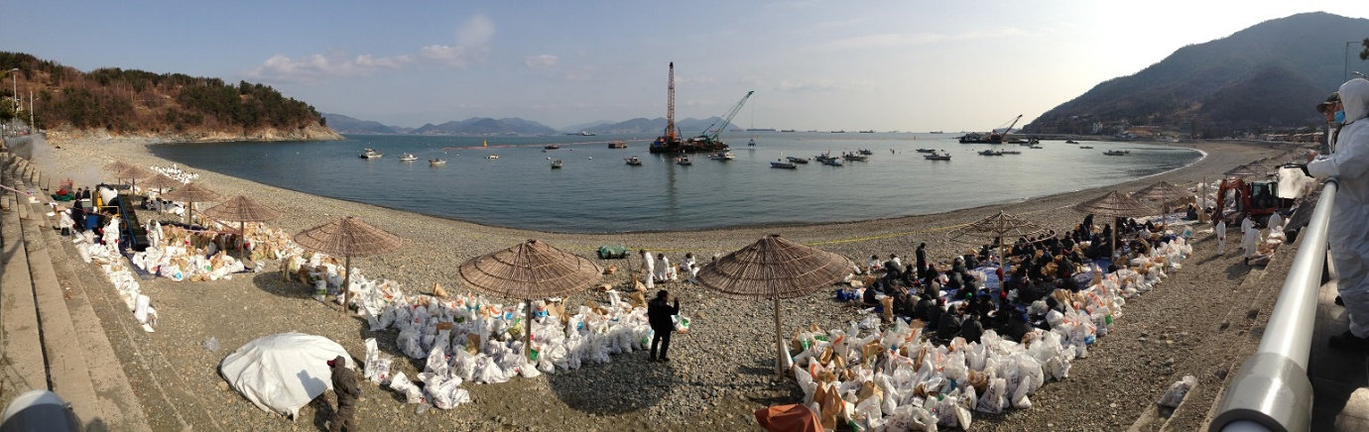
Mark said “We put together a truly independent judging panel, some with a focus and experience on the cinematography, and some with a technical experience on oil spill response. The films needed to score highly in both categories to be an overall winner, and that’s where the ITOPF Films did so well. We had some other excellent submissions that excelled either in the cinematography or in communicating the technical aspects of spill response, but none of the others managed to combine both aspects to produce 3 rounded films which we felt were worthy winners”.

Alex Hunt, project manager for the film series, concluded “It was fantastic to see the way in which Mark worked to raise the bar in the Film Festival. It really did feel like you were going into a cinema when you stepped in to the room with full screen, excellent sound, comfy chairs and even the smell of freshly popped popcorn. This confirmed to us the increasing importance of effective communication through films and imagery in preparing for effective response to marine oil spills.”

13th May 2014

Notes for Editors:
ITOPF Film Series – Response to Marine Oil Spills
ITOPF has launched a new series of seven films on oil spills, their impacts, effective response and compensation. The films are designed to promote good practice and raise awareness of some of the issues involved in oil spill response. They incorporate footage shot on location at oil spills worldwide since 2007, combined with interviews and archive film from the major incidents of the last 45 years.
The films are approximately 20 minutes long and cover the following topics:
- 1. Introduction to Oil Spills
- 2. Aerial Surveillance
- 3. At-Sea Response
- 4. Shoreline Clean-Up (Coming soon)
- 5. Waste Management (Coming soon)
- 6. Environmental Impacts (Coming soon)
- 7. Oil Spill Compensation (Coming soon)

The first three films are currently available to view on-line from ITOPF’s website. The remaining four films will be available in June.
The seven films will also be released as a single DVD with subtitles in Chinese, French, Spanish, Arabic and Korean. These will be available in mid-June, priced £10 inc P&P. To register your interest, please contact Melanie Keeble at ITOPF (melaniekeeble@itopf.com).

ITOPF

1. The International Tanker Owners Pollution Federation Limited (ITOPF) was established as a non-profit making service organisation in 1968. In the early days its principal function was the administration of the TOVALOP voluntary oil spill compensation agreement. However, for the past forty years ITOPF has also provided a broad range of technical services in the field of marine pollution to and on behalf of shipowners, their P&I insurers and other groups such as the International Oil Pollution Compensation Funds, as well as to the community at large.

2. ITOPF's Membership currently comprises some 6,350 owners and bareboat charterers of approximately 10,950 tank vessels with a total gross tonnage of about 340 million GT. The organisation also benefits from the participation of 721 million GT of non-tanker tonnage owned and operated by its Associates.

3. ITOPF's priority service is responding to accidental marine spills and the organisation's team of highly experienced technical staff are at constant readiness to travel anywhere in the world at a few hours’ notice. Since 1978 ITOPF staff have attended on-site at over 700 incidents around the world, giving the organisation unparalleled practical experience of the realities of combating major marine spills. ITOPF also:

- assesses the damage caused by spills to the environment and economic resources;
- provides advice on the technical merits of claims for compensation;
- conducts contingency planning, advisory and training assignments;
- produces a wide range of technical publications; and
- maintains various databases as well as a website at http://www.itopf.com

4. For further information contact:

Dr Karen Purnell (Managing Director)
Miss Deborah Ansell (Information Officer)
The International Tanker Owners Pollution Federation Limited (ITOPF)
1 Oliver’s Yard, 55 City Road, London EC1Y 1HQ

Tel: +44 (0)20 7566 6999
Fax: +44 (0)20 7566 6950
Email: deborahansell@itopf.com
Web: www.itopf.com

