Downward Trend in Spills is Maintained Despite Blip

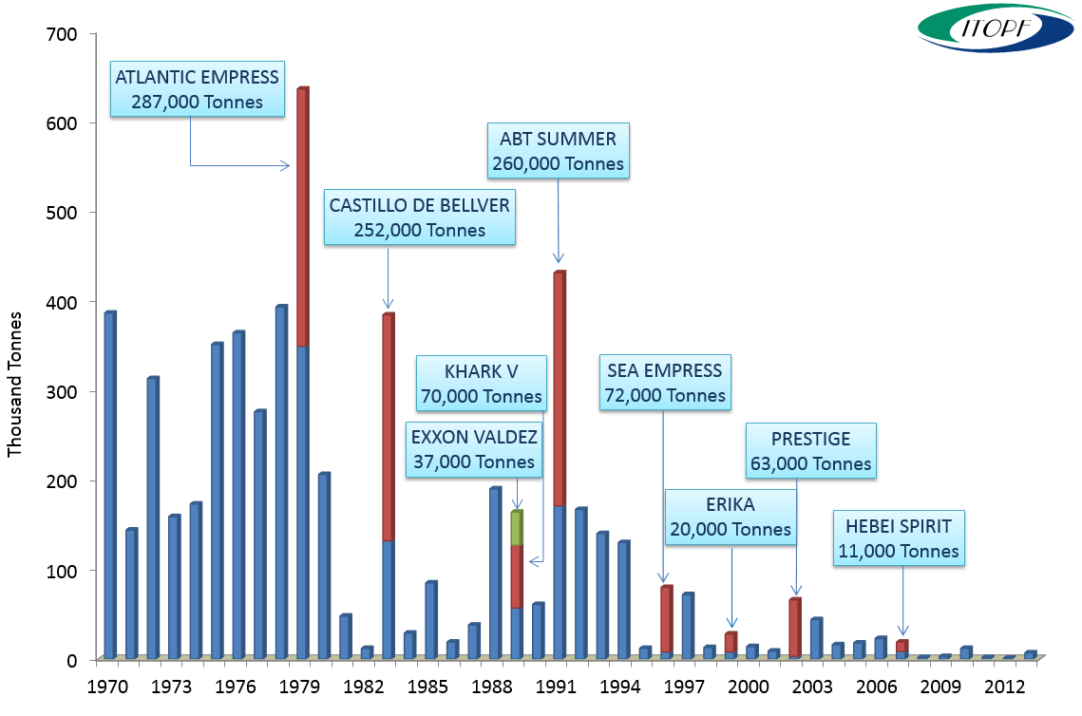
Quantities of oil spilt >7 tonnes (rounded to nearest thousand), 1970-2013

ITOPF's tanker spill statistics released today showed a slight increase in the number of large spills from tankers in 2013 compared to the previous two years but the downward trend is maintained.

Although the volume of oil spilt is also up on the last two years, the total quantity spilt so far this decade is only a sixth of that spilt for the same period in the previous decade.

Three oil spills of 700 tonnes or more occurred last year with one incident accounting for the vast majority of the total. In October the MT YONG WIN 3 reportedly capsized and sank spilling an estimated 5,000 tonnes of diesel oil. Two other incidents resulted in a spill of about 1,000 tonnes of fuel oil and 800 tonnes of bitumen respectively. These incidents illustrate the unpredictability of spills and the importance of preparing to respond to the range of oils involved.

14th January 2014
Notes for Editors:
ITOPF maintains a database of oil spills from tankers, combined carriers and barges. This contains information on accidental spillages since 1970, except those resulting from acts of war. The data held includes the type of oil spilt, the spill amount, the cause and location of the incident and the vessel involved. For historical reasons, spills are generally categorised by size, small (<7 tonnes or <50 bbls), medium (7-700 tonnes or 50-5,000 bbls) and large (>700 tonnes or >5,000 bbls), although the actual amount spilt is also recorded. Information is now held on nearly 10,000 incidents, the vast majority of which (81%) fall into the smallest category i.e. <7 tonnes.

Further details on the number and quantity of spills from tanker accidents since 1970, together with figures and tables, are available on the statistics page of ITOPF’s website.

ITOPF

1. The International Tanker Owners Pollution Federation Limited (ITOPF) was established as a non-profit making service organisation in 1968. In the early days its principal function was the administration of the TOVALOP voluntary oil spill compensation agreement. However, for the past forty years ITOPF has also provided a broad range of technical services in the field of marine pollution to and on behalf of shipowners, their P&I insurers and other groups such as the International Oil Pollution Compensation Funds, as well as to the community at large.

2. ITOPF's Membership currently comprises some 6,360 owners and bareboat charterers of approximately 10,950 tank vessels with a total gross tonnage of about 340 million GT. The organisation also benefits from the participation of 690 million GT of non-tanker tonnage owned and operated by its Associates.

3. ITOPF's priority service is responding to accidental marine spills and the organisation's team of highly experienced technical staff are at constant readiness to travel anywhere in the world at a few hours’ notice. Since 1978 ITOPF staff have attended on-site at over 700 incidents around the world, giving the organisation unparalleled practical experience of the realities of combating major marine spills. ITOPF also:

- assesses the damage caused by spills to the environment and economic resources;
- provides advice on the technical merits of claims for compensation;
- conducts contingency planning, advisory and training assignments;
- produces a wide range of technical publications; and
- maintains various databases as well as a website at http://www.itopf.com

4. For further information contact:

Dr Tim Lunel (Support & Development Director)
Miss Deborah Ansell (Information Officer)
The International Tanker Owners Pollution Federation Limited (ITOPF)
1 Oliver’s Yard, 55 City Road, London EC1Y 1HQ

Tel: +44 (0)20 7566 6999
Fax: +44 (0)20 7566 6950
Email: deborahansell@itopf.com
Web: www.itopf.com

