ITOPF Publishes Tanker Spill Statistics for 2021

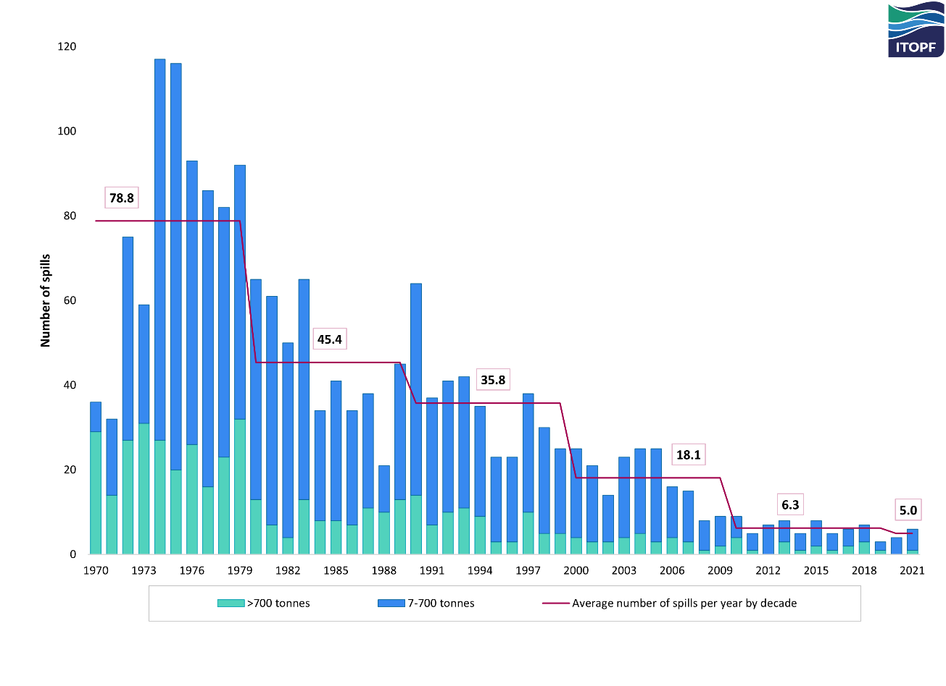
Number of medium (7-700 tonnes) and large (>700 tonnes) tanker spills, 1970 -2021

Data from ITOPF shows that six oil spills over 7 tonnes were recorded from tanker incidents in 2021. This is a slight increase on 2020, but on a par with the average for the 2010s and a dramatic reduction from the numbers reported in earlier decades, as illustrated above.
Only one of the six incidents in 2021 resulted in a spill greater than 700 tonnes (classified as a ‘large’ spill). This occurred in Asia in April and involved heavy crude oil.
The five other incidents (classified as ‘medium’ spills) involved crude, slurry and non-persistent oils.
The total volume of oil lost to the environment from tanker spills in 2021 was approximately 10,000 tonnes, the majority of which was spilt in the one large incident. This figure is higher than the previous two years but remains a fraction of the 1.7 billion tonnes of oil that is transported by sea each year.
Despite some annual fluctuations, the number and volume of oil spills from tankers has plummeted since ITOPF’s records began half a century ago and is largely stabilising at a low level. This reduction has been driven by positive change from the shipping industry, supported by governments, and their ongoing commitment to exploring and investing in ways to improve maritime safety and environmental protection.

It is important to note that although ITOPF attends incidents from all types of ship, for historical reasons the annual statistics publication reports incidents involving tankers only. Accidents involving non-tank vessels which carry oil as bunker fuel may also be a source of pollution. Other non-shipping sources, such as pipeline spills and oil industry activities, as well as natural seepage, also contribute towards the global input of oil into the marine environment.

Notes for Editors
ITOPF maintains a database of oil spills from tank vessels, including combined carriers, FPSOs and barges. This contains information on accidental spillages of persistent and non-persistent oil since 1970, except those resulting from acts of war. The data held includes the location and cause of the incident, the vessel involved, the type of oil spilt and the spill amount. For historical reasons, spills are generally categorised by size, <7 tonnes, 7–700 tonnes and >700 tonnes (<50 bbls, 50–5,000 bbls, >5,000 bbls), although the actual amount spilt is also recorded. Information is now held on over 10,000 incidents, the vast majority of which fall into the smallest category i.e. <7 tonnes.
We regret that it is not possible to provide direct access to our database or to release the names of individual tanker spills.
Further details are available on the statistics page of our website. The full 2021 report will be available here shortly.
Notes on ITOPF
1. Established in 1968, ITOPF is maintained by the world’s shipowners and their insurers on a not-for-profit basis to promote effective response to spills of oil, chemicals and other substances in the marine environment.

2. ITOPF was originally known as the International Tanker Owners Pollution Federation, but in 2018 officially changed its name to ITOPF Ltd.

3. ITOPF's Membership currently comprises around 8,250 owners and bareboat charterers of approximately 13,600 tank vessels with a total gross tonnage of over 455 million GT. The organisation also benefits from the participation of over 875 million GT of non-tanker tonnage owned and operated by its Associates.

4. ITOPF's priority service is responding to accidental marine spills from ships. ITOPF staff have attended on-site at over 800 incidents in 100 countries, giving the organisation unparalleled practical experience of the realities of combating marine spills.

ITOPF also:

- assesses the damage caused by spills to the environment and economic resources
- provides advice on the technical merits of claims for compensation
- conducts contingency planning, advisory and training assignments
- is a primary source of information on ship-source spills through its technical publications, films and website (www.itopf.org)

5. For further information contact:

Oli Beavon, Managing Director
Deborah McKendrick, Senior Information Officer
ITOPF Limited
1 Oliver’s Yard, 55 City Road, London EC1Y 1DT, UK
Tel: +44 (0)20 7566 6999
Email: deborahmckendrick@itopf.org
Web: www.itopf.org

This figure is for crude oil only and does not include petroleum products. Source: Review of Maritime Transport 2021 | UNCTAD

